**Transitioning to SIMPLE by Classroom Monitor – School Staff Email Copy**

**3.1 Logging out of the old system (including the App) – send before the end of term**

Subject: IMPORTANT: Please act before the end of term

We are really pleased to confirm that the school will be moving to the new version of Classroom Monitor on **[insert go-live date here]**. In preparation for this it is important that you **complete these three steps before the end of term:**

1. Please ensure that all assessments are entered before the end of term. Any data entered into the existing system after the end of term will not be carried over into the new system.
2. All users need to log out of the current version of Classroom Monitor by the end of term. Click on ‘Logout’ in the top right-hand corner of the platform:

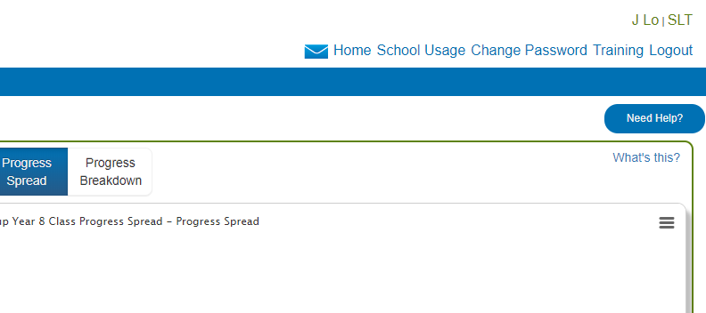

1. If you use the Classroom Monitor mobile App (on a phone or tablet), please ensure you have logged out of this by clicking on the menu in the top left of the app and then clicking on the power button within the App menu:

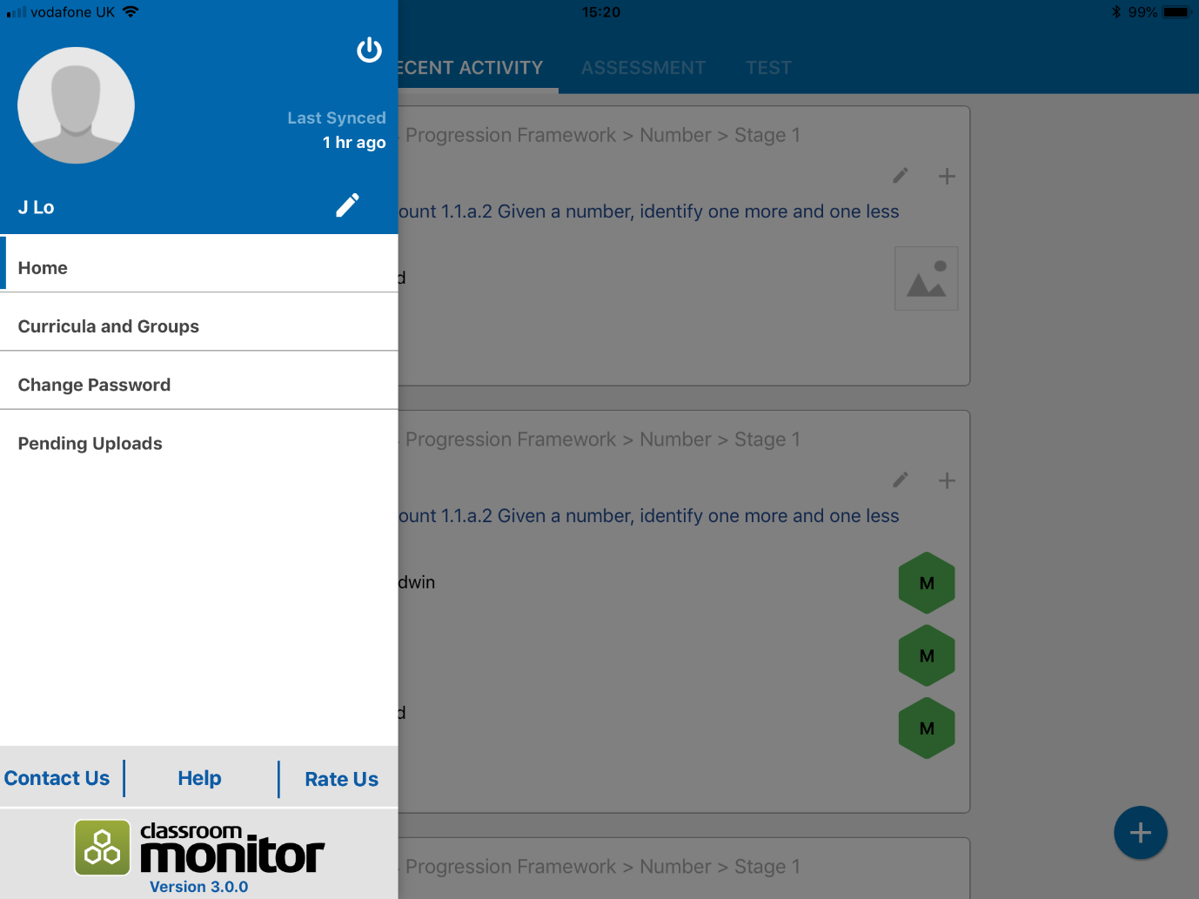

Thanks

* 1. **Logging into the new system – send before your go-live date**

Subject: Logging into the new Classroom Monitor platform

We will be going live with the new Classroom Monitor platform on **[insert go-live date].**

Your existing username and password will no longer work on the new system.

On the go-live date you will be sent an email from Classroom Monitor ([sender@classroommonitor.co.uk](mailto:sender@classroommonitor.co.uk)) confirming that your staff email is your Username and you will also be provided a link to create your new password.

Thanks

* 1. **Making best use of online training and videos**

Subject: Getting started with the new version of Classroom Monitor

To help you get started with SIMPLE by Classroom Monitor, please make yourself familiar the new help and support resources.

To access the help materials visit <https://classroommonitorhelp.freshdesk.com/support/home> or you can access them directly by clicking on the question mark found throughout the platform:

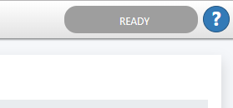

The Knowledge base provides help guides and videos for all areas of Classroom Monitor and has specific materials depending on your role: CM Leader/Admin, Teacher and SLT.

This is also the area where you can search for solutions relating to Classroom Monitor or if you need further help you can also raise and track a support case.

If you need to raise a support case your will first need to register an account for the Classroom Monitor Support Platform (existing support platform accounts will not work on the new version). To do this click on SIGN UP in the top right and provide the following details:

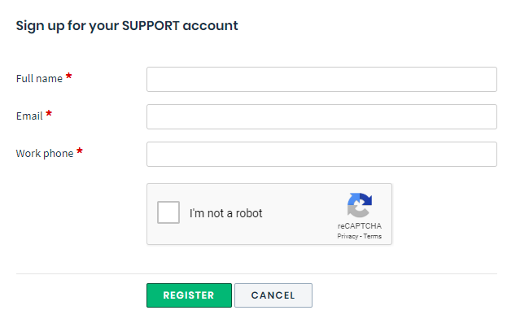

Thanks